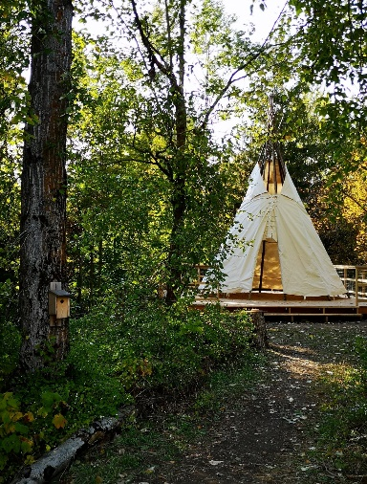
Canyon-Lister Elementary School: Aboriginal Education Program
2019-2020

Hello everyone!!! I hope that this finds you healthy, happy and finding moments of joy in each day.

Even though our face-to-face year together has been cut short, so many beautiful moments of learning and growing have already been shared, and we will be continuing to support our students until the end of June.
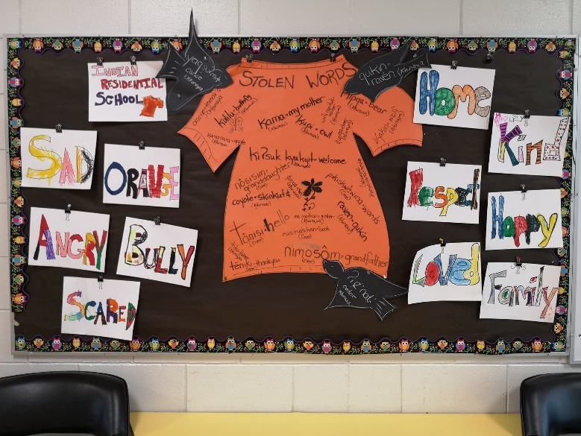
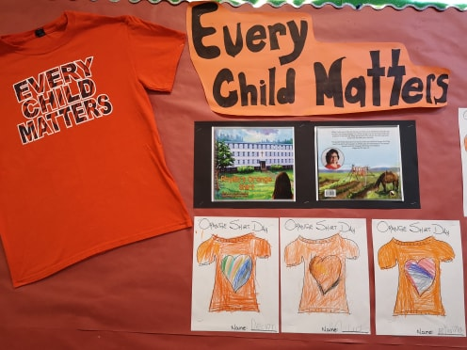
Our year began with the acknowledgement of our annual Orange Shirt Day. Bulletin boards graced Orange Shirts, large and small, filled with words and colour, sharing messages of understanding and empathy, reconciliation and hope. Our assembly shared the story, Stolen Words. A grandfather that had his traditional language ‘stolen’ from him, was given the gift of words and culture by his granddaughter who learned about her traditional Cree in her school classroom!

An amazing, beautiful, spacious platform was built in our forest classroom over the summer. Huge thanks to our summer and maintenance staff for their amazing work. Thank you to Huscroft Mill for donating the lumber and fundraising, supply volunteers Kristina Leidums, Michelle and Bentley Bredy. In October, our brand new tipi was assembled by a local mentor and some of our Grade 6/7 students, but was promptly brought crashing into the ground during a weekend wind storm. Not to worry! Our beautiful tipi will be repaired and waiting for us in September!

There were beautiful native plant species signs made, incorporating both English and traditional Ktunaxa names for the plants during the fall. We look forward to some traditional plant use learning, walks amongst the forest trails and erecting our beautiful signs in the fall.

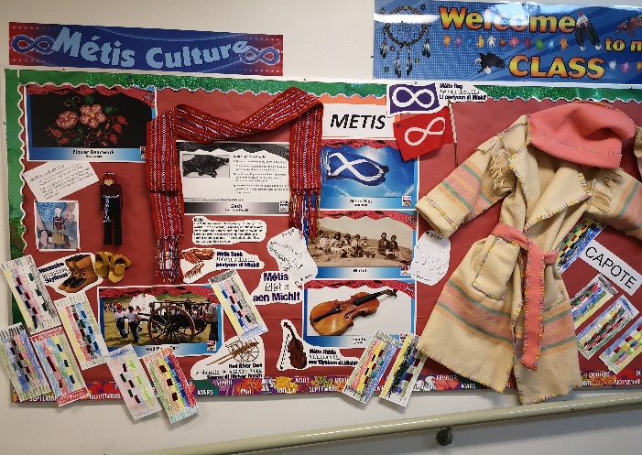
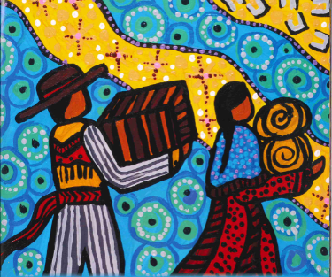
Metis Awareness month included sharing the stories and lessons of the Metis people. Our daily announcements began with Tawnshi kiya mataen
(good morning in the Metis Language of Michif) and together we heard poetry, stories, about athletic heroes and the fiddle music of the Metis people. Did you know that Terry Fox, a national hero, was Metis? The most beloved fiddle tune –Red River Jig! Our assembly shared the traditional story of the Diamond Willow Stick reminding us that we need to always do our best, that what we gift the world will gift us in return. A beautiful life reminder.

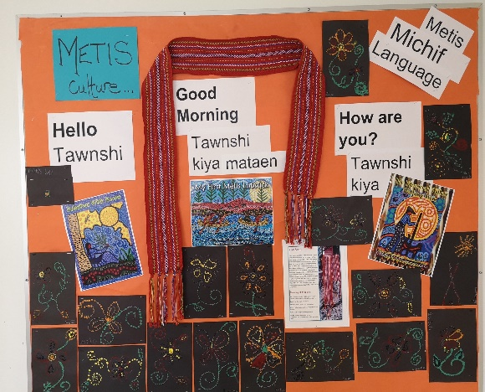
Miss King’s Grade 2/3 class began their New Year putting together their Metis Treasure Book. We enjoyed our weekly story times together, learning about the Metis Jig and fiddle music, the Metis Sash, flag, mittens and so much more. Workbooks gathered information and were decorated with bright colours! I hope you are able to continue working on your books from home. I will be working on connecting you to even more stories to listen to, from home! Details to follow!

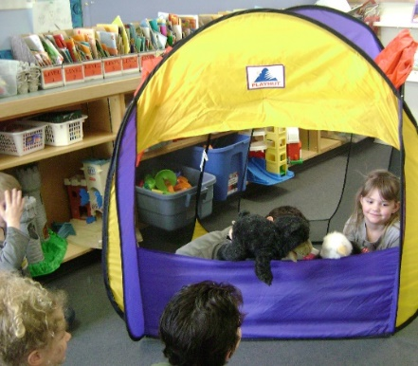
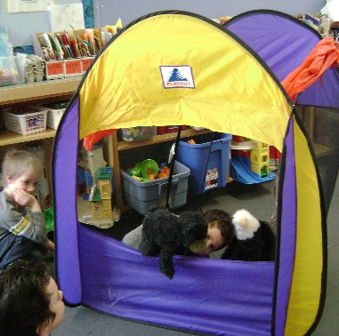
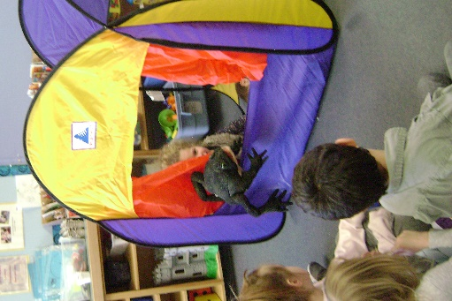
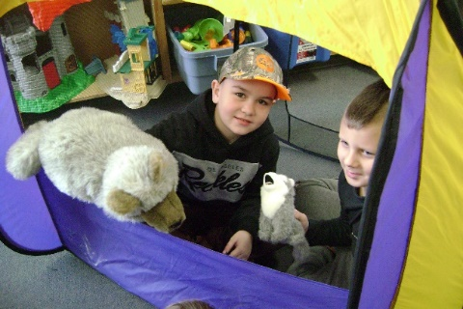
Ms. Zefflie’s K/1 class celebrated the finale of the Learning Journey Series by acting out the roles of the many story book characters they’d been learning about. The lessons of salmon, bear (nipqu) and eagle, beaver and frog, wolf and coyote, porcupine and hummingbird became real life drama using our classroom puppet theatre. So many beautiful moments of learning and laughter. Lessons reinforced the Traditional Acknowledgement – that we live, work and play upon the traditional lands of the Ktunaxa peoples.
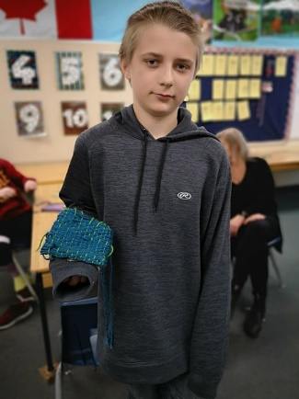
Metis Mittens; works of art reflecting the tradition of Metis beading as well as being gifts of love and belonging. Mrs. Blackmore and Mr. Ewashen/Mitchell’s classes worked diligently to draw patterns, cut materials, sew and bead the ‘traditional’ way. Well, there may have been a little artistic license!! Some have completed their mitts, but for some this has become an at home project. Student Metis mitten ‘kits’ have been sent home including the work you have already accomplished as well as the materials you will need to complete your beautiful mittens. Some students using the traditional weaving style of the Salish peoples made woven bags! I only have one picture but they were all looking pretty terrific! I would ask that once complete, send a photo of your accomplishment
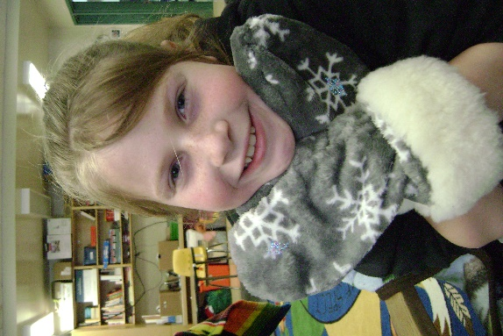
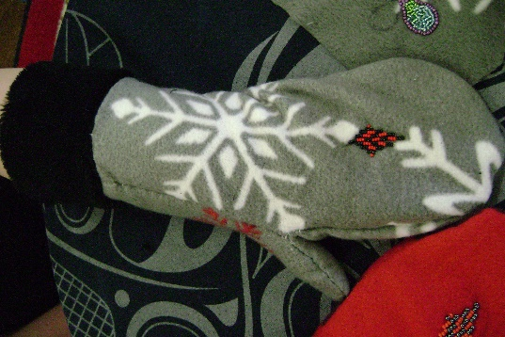
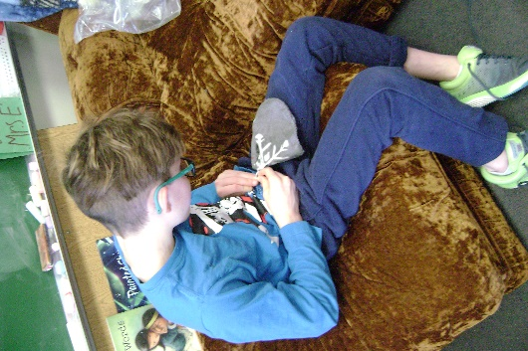
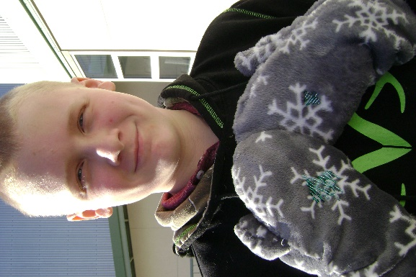
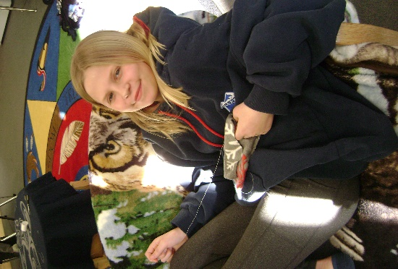
to Mr. Ewashen. I would love to see them too! Remember, I am just a phone call away for any assistance you may need!
(250)428-41610.
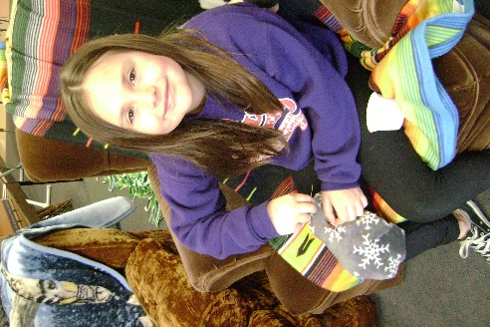
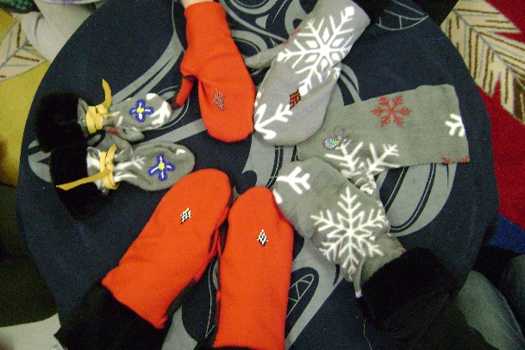

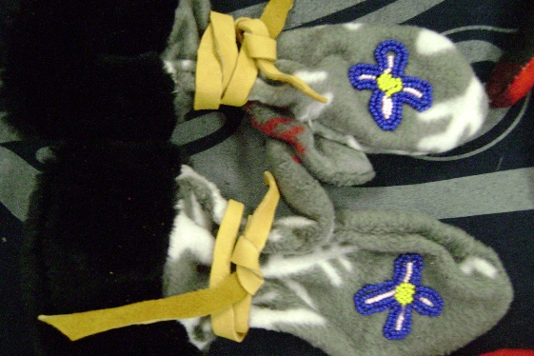
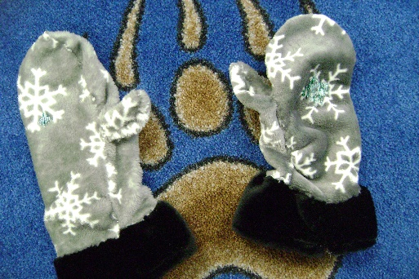
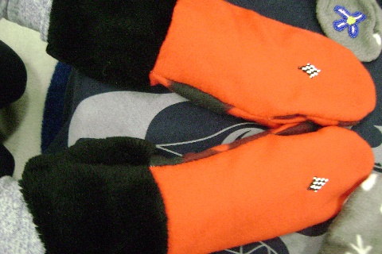
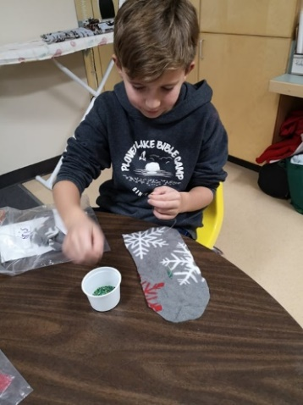
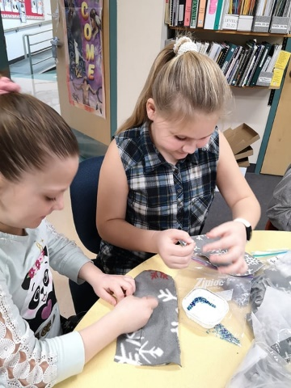
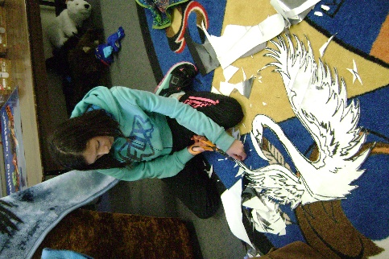
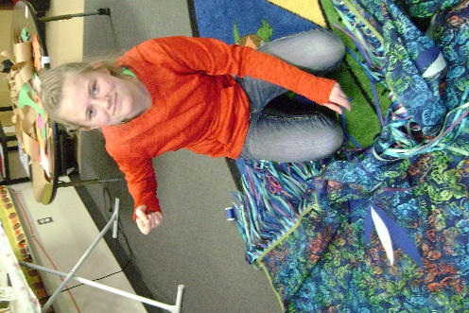
Ms. Danforth’s class studied peoples through the ages. Incorporated into the class were lessons on the similarities to the Inuit peoples’ traditions. Each student was given a piece of soapstone and carving utensil to allow their imaginations to take over!
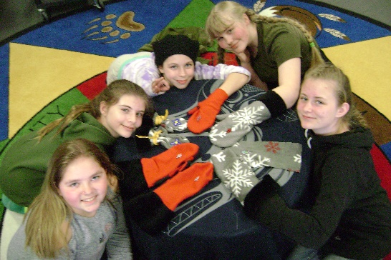
All the while, there was the Regalia making …. learning about the Seven Traditional Teachings of honesty, truth, humility, courage, bravery, love and wisdom and their importance when ‘telling’ your story with your Regalia. There were ribbon shirts, shawls, moccasins. Many were completed. Many were still being worked on and many were awaiting the return from Spring Break to begin theirs. Please know that they will be waiting for you when you return!
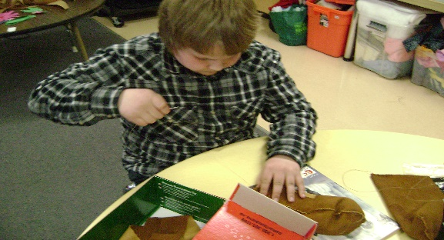
It is a difficult time for many, here and around the world. I have been so very thankful for all of you this year. We missed out on several upcoming events that were planned in the months ahead, but this is when our teachings take precedence; the humility to know there are things we cannot change, the bravery to move forward, the courage to take the steps necessary care for yourselves, your loved ones and your community.
Our ‘events’ will patiently wait for us to catch up! In the meantime, I will be connecting with families, teachers and students to ensure you have lessons that would reflect some of the teachings you would have learned throughout the year. All of you will have been contacted by your teachers by now assessing support, tech and otherwise, needs you may be experiencing. Please know that I am here, currently in the school building. You may reach me during Monday through Friday at 428-4161. If there is ANY way in which I may assist you, please call.
Take good care, Mrs. Ewashen

