Be the Change – Newsletter – June 2022
It has been another school year filled with many acts of change.
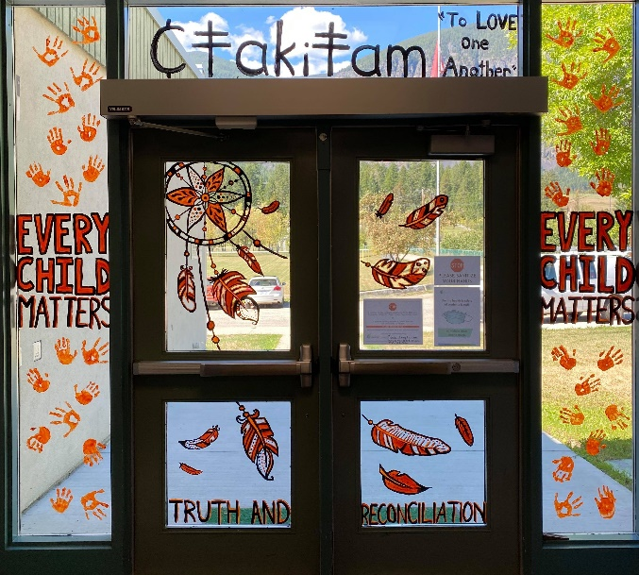
Our year began with our entire school honouring Orange Shirt Day to remember the history of how Indigenous peoples were treated in this country; the truths that are often hidden or not spoken of. Together we shared and honoured the stories of the survivors of Indian Residential School. The pandemic curtailed us from assembling together but ‘together’ we learned within our separate classes the true stories of residential school and the long lasting intergenerational trauma that has resulted. Art was created and lined our hallway walls – including the front entrance !
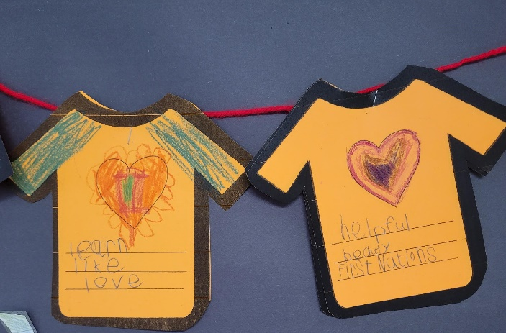

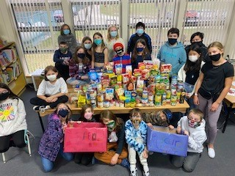
Senior Be the Change students (Grades 5-7) participated in our annual WE – Scare The Hunger campaign collecting approximately 150 articles of nonperishable food items that were then donated to our local food bank – Gleaners.

Remembrance Day was spent at the cenotaph on November 11th, with handmade cards given out to veterans thanking them for their service and bravery – helping to make this a safer, free country in which to live. There were conversations with veterans which lead to better understanding for our young ones and for the veterans, a reminder that their stories are still being shared with the younger generations.
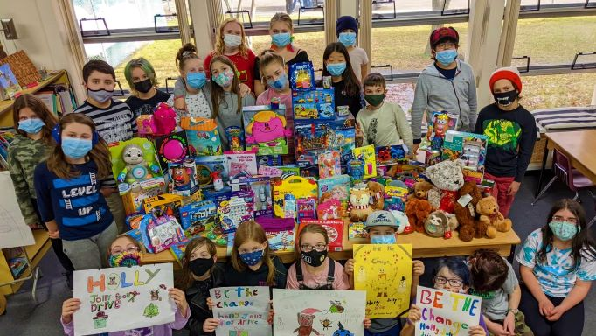
We then connected with our community Christmas Hamper organization to collect well over one hundred toy items to add to the food hampers that were given to families in need – creating a bit of Christmas joy.
For emergency care providers (firemen and women, police, ambulance, hospital staff, senior care homes), there were creatively hand made Christmas cards thanking them for their kindness, dedication and patience. There was even a bit of Christmas caroling for the senior homes – from the outside looking in!
To bring attention to the United Nations’ goals that focus upon clean water and sanitation, students wrote and signed a joint letter to the Prime Minister speaking about the fact that water is life and to remind him of his government’s promise to address all boil advisories currently active on reserves throughout Canada. We did receive a response from the Prime Minister’s Office assuring students that this was still a top government priority and that work was in progress.
After Christmas, our Jr. Be the Change group (Grades 4 & 5) continued the theme of putting plans into action to address the UN’s identified inequities – in food, health care and education. First, they studied the differences between the food costs in our home valley, Creston B.C., versus the food costs in Nunavut. They were shocked to find the costs being two, three and sometimes five times higher in Iqaluit. It left them wondering how families could actually afford food. We learned that children were often dependent upon school breakfast and luncheon programs to have at least one full, healthy meal per day. A bulletin display was created as an educational tool to be used by the school as a whole. We also joined the Birthday Box program – providing the birthday party supplies to a young boy living in Nunavut. The children had a great time choosing items for the box and including birthday cards and wishes. Connections, connections.
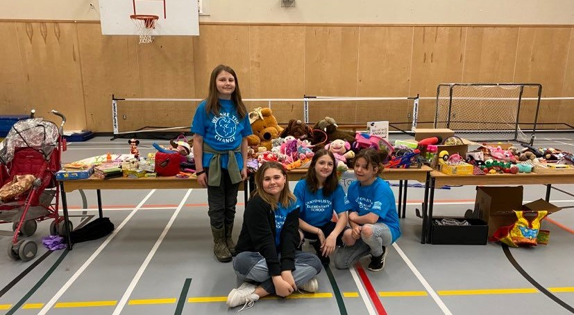
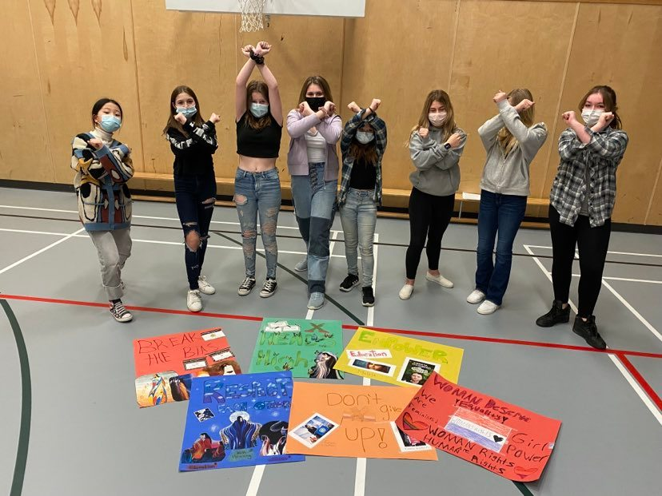
Our girls’ Friendship Friday group presented the assembly for International Woman’s Day in March. Break the Bias was something that was researched and then shared throughout the school using posters and then educating students at a school wide assembly about the unique, discriminatory challenges facing girls and women around the globe. We were so proud of their passion and determination to create a world that was fair and celebratory of all genders!
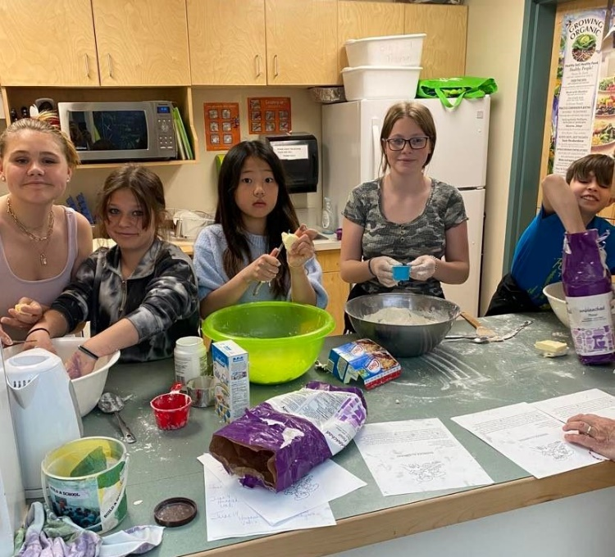

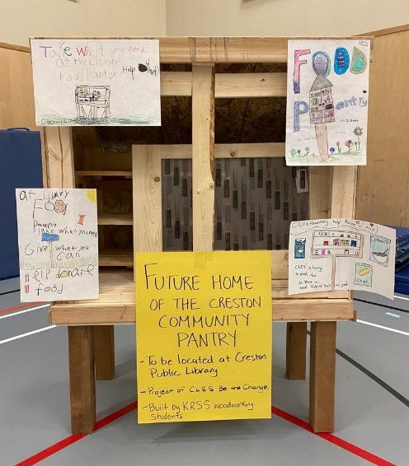
Fundraisers were held throughout the year to support a variety of our endeavours – bannock sales, hot dog sales, garage sales to name a few. The garage sale was specifically to assist refugees donating to the Global Giving -Ukranian Crisis Relief Fund.
After reading the Metis Giving Tree by Leah Dorion, our Jr. Be the Change group decided creating a Community Food Pantry was a priority! The vision was a large one, but they planted the seed – requests went out to the high school woodwork class to build a pantry and our students participated in a zoom meeting with the local Community Development organization ultimately resulting in the official approval to place the pantry in a central location, just behind the library along a main walk path.
Spring Break brought great news – masks no longer required and gatherings, were once again allowed.
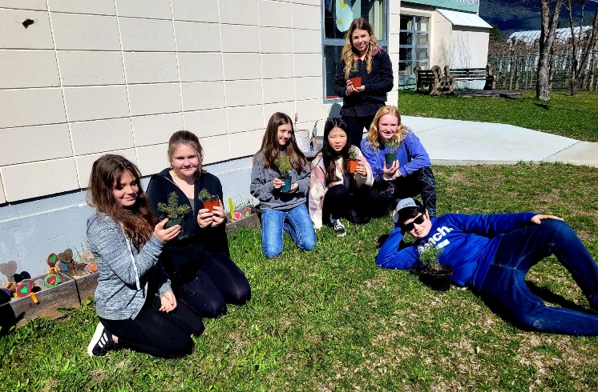
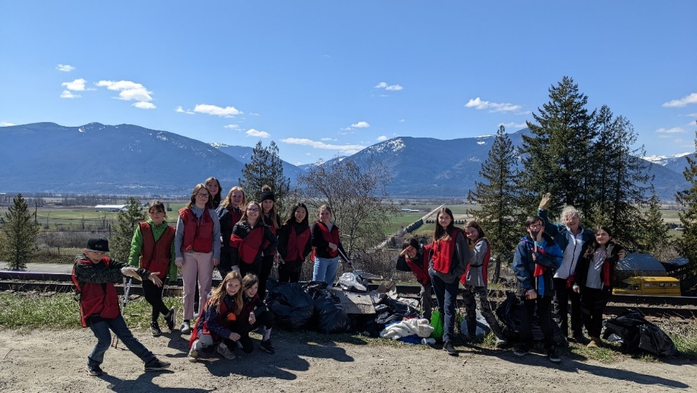
Sr. Be the Change students thought a fresh start was in order and took a field trip to town – to pick up garbage that had drifted there or was, sadly, tossed out the windows by drivers passing by. Hours were spent picking up garbage and then the Town of Creston joined in by properly disposing of the mountain of garbage that was collected! The students realized that the simple act of picking up trash helps our environment, our animals, our water and ultimately the people who call this valley home. Passers by honked their cars in gratitude.
Trees were planted by students to continue the theme of giving back to nature, understanding that trees will always be an integral part of healing our planet.

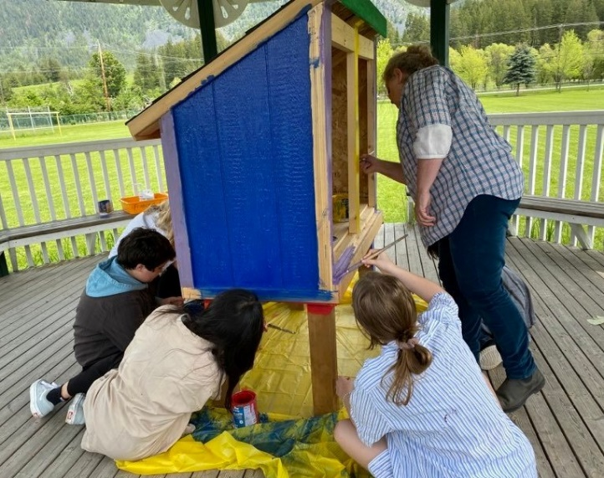
Senior students carried on the vision that began with our Jr. Be the Changers - finishing the Community Pantry. A grant from our Regional District was gifted to us to fill up the pantry, the pantry was built and painted. In the Fall of 2022, the pantry will be installed.

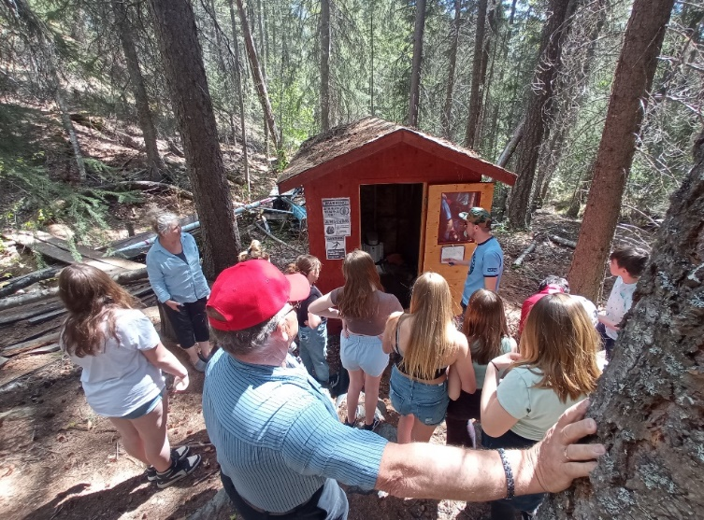
To round out the year, Sr. Be the Change students celebrated by taking a day’s field trip to Blue Lake. There, they participated in a water stewardship program learning about water sustainability and the use of hydro electricity. They then challenged themselves to a vertical rope climbing course. Fears were conquered and personal goals were met.
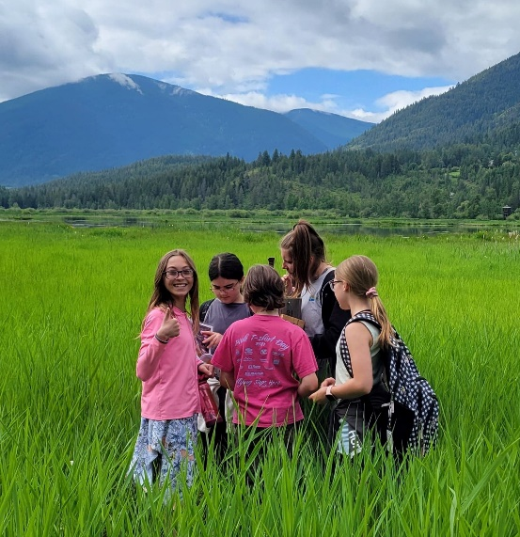
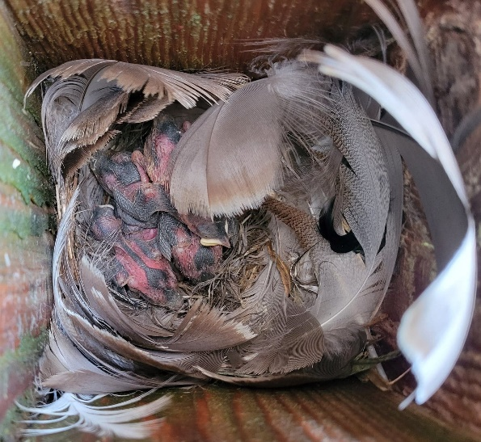
Remembering our Jane Goodall Roots and Shoots promises, our younger Be the Change students visited our local Creston Valley Wildlife Center – our local marshlands. They participated in a swallow box count documenting the progress, or lack thereof, of the swallows within the marsh. These results are sent to a provincial office where results are used to plan for changes occurring within the wetlands, climate changes, etc.. The afternoon included a wetland education tour by canoe learning about the intricacies of the wetlands, biodiversity and how important wetlands are to the health of our overall ecosystem.
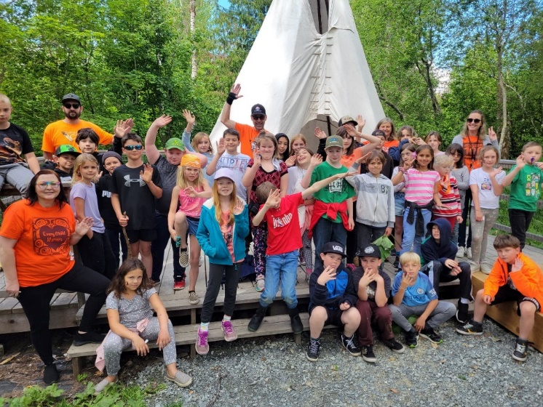
At the end of our school year end classes participated in a Reconciliation Walk/Run – called the Wuqanqankimik Run – Taking Long Strides in the Ktunaxa Language. Our school learned about truth and reconciliation within their classrooms in the morning but as a school we ‘walked the talk’ – holding promises of action! Promises were pledged to take to make this world a better, kinder, inclusive place.
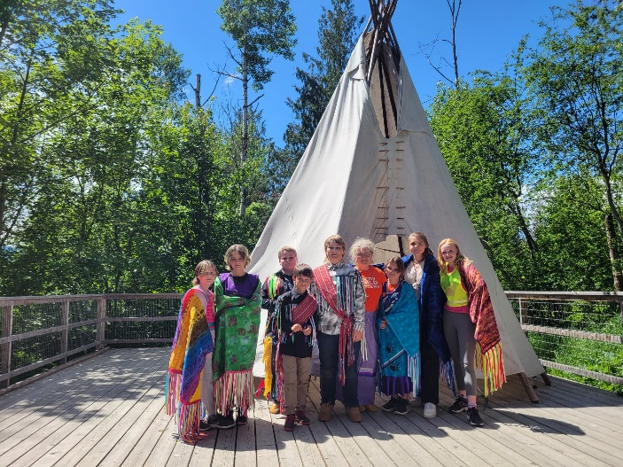
Celebrating National Indigenous Day, in the afternoon, we danced with much love in our hearts honouring and celebrating the Indigenous cultures of this land. Here in our valley – we are thankful to live, work and play upon the traditional lands of the Ktunaxa peoples.
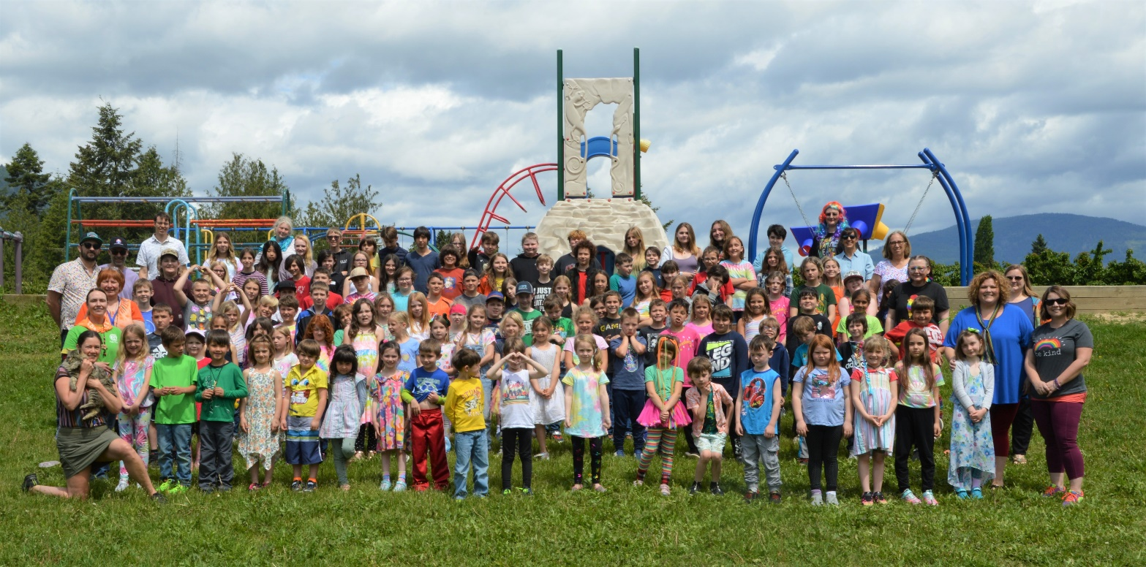

Our school, Canyon Lister Elementary, and our Be the Change student volunteers try to make this world a better place every day. Next year is another year that will be filled with kind, caring, action oriented, leadership filled activities that will again focus upon local, national and international goals.
Written by Laurel Ewashen
Aboriginal Education and Family Youth Worker

