BE THE CHANGE
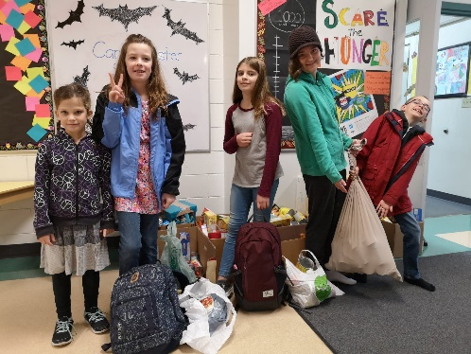
…….. OUR YEAR 2018-2019 DRAWS TO A CLOSE

Every year is an inspirational one and this year our students inspired our entire valley!

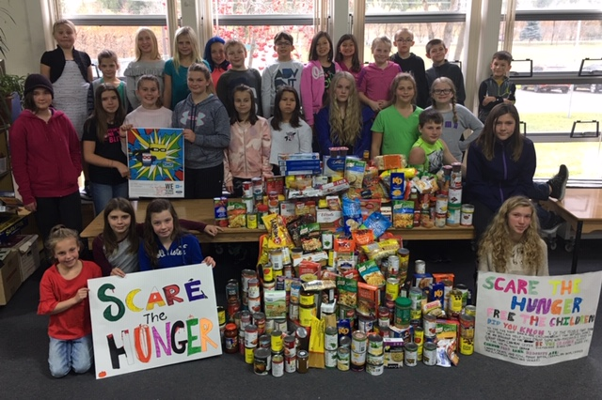
One of the first actions students became involved in was our annual Scare Hunger campaign. Dedicated volunteers collected cans of food in place of the usual sweet treats during trick or treating. The school as a whole, gathered hundreds of cans of food which were then donated to our local Food Bank. Students were even interviewed by our local radio station wondering what our Be the Change student group was all about!
Caring for our neighbours is where it all began …

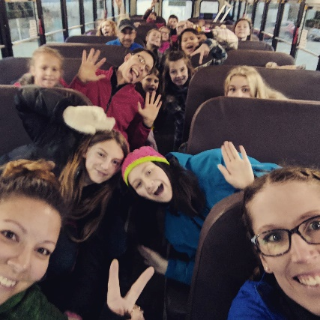
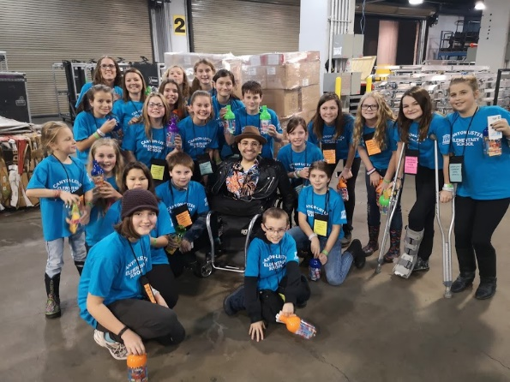
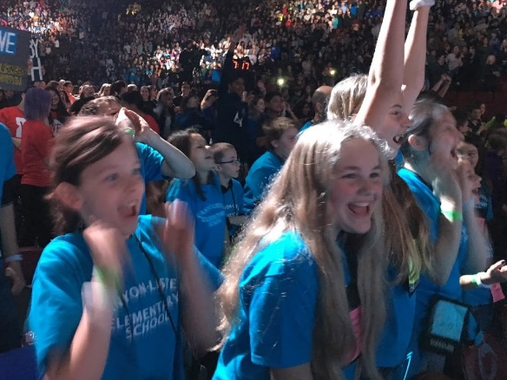
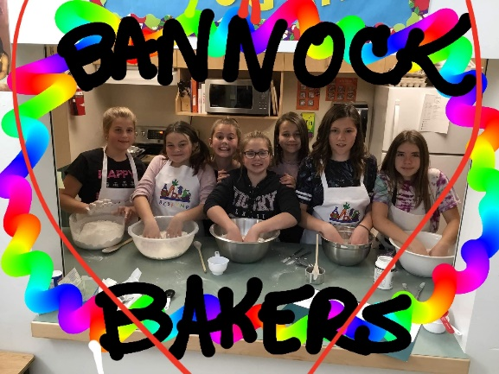
All of a sudden, October took on a life of it’s own. Fundraising to attend We Day was a little all consuming, but it was so worth it! We Day is an inspirational celebration of young people’s efforts to change the world in a positive way. This year, our students were gifts with almost 2 dozen tickets to attend We Day in Vancouver! Not only that, as a surprise to the students they sat on the floor, a heartbeat away from most performers, received backstage passes and became a highlighted school on the international stage of We Day – 20,000 in the arena and televised across the nation! Wow! Pretty amazing and pretty humbling! Thanks to Miss Rachel, Ms. DeBoon, Mr. Ewashen and Mr. Mitchell for helping our students arrive safely and celebrate their successes with them! Watching Preston break out his dance moves on the We Day stage or seeing (and hearing ) the screams of surprise when students heard their school’s name being recognized ….a moment I will never forget! Well done everyone!
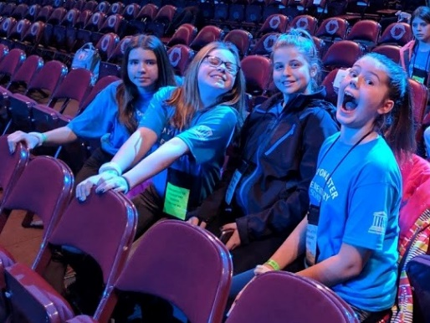

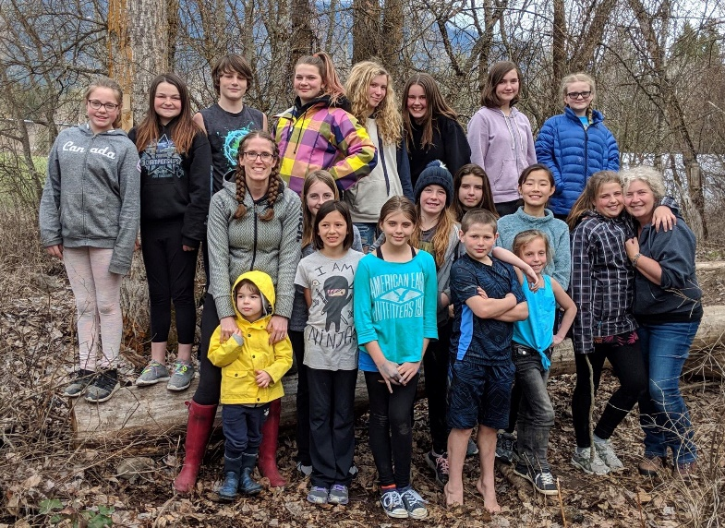
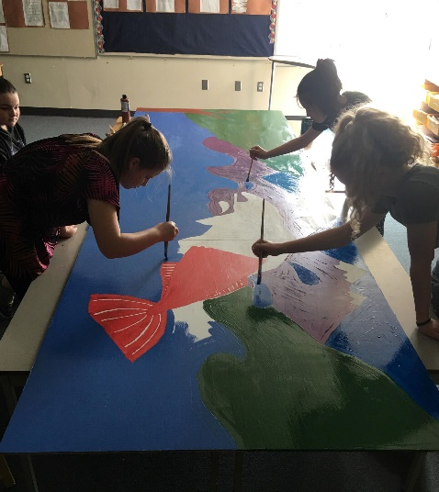
Each year principal goals are set by the students. We all talk about different possibilities and together decisions are made. This year, one of the students’ primary goals was to raise $1200 towards the purchase of a Shelter Box. The ‘Box’ is a portable metal container that holds many of the necessities of life for those in need due to natural or man made tragedies: a shelter, sleeping material, cooking facilities and materials, light, food storage and the list goes on. Hand in hand with this project was a challenge – to go ‘Off Grid’. Our senior Be the Change Students took on this challenge volunteering to spend 12 hours on a day off of school to hang out with we adults (Thank you Miss Rachel, Ms. DeBoon, Mr. Ewashen ) learning that electricity is a gift and that doing without is a reality for the majority of the world’s population. Realizing that we were ‘cheating’ on many levels (running water, a heated building) we spent the day picking up litter at our school, creating beautiful projects made out of plastic to create awareness, building bird and bat houses and the list goes on. We spent the day interacting, talking with each other, making decisions with one another, playing, working – a great day! To top it off - $1400 was raised by donations the students sought out and voila, their goal to purchase a Shelter Box was reached. We have since received a certificate thanking us and asking to use our school as an example to inspire others!
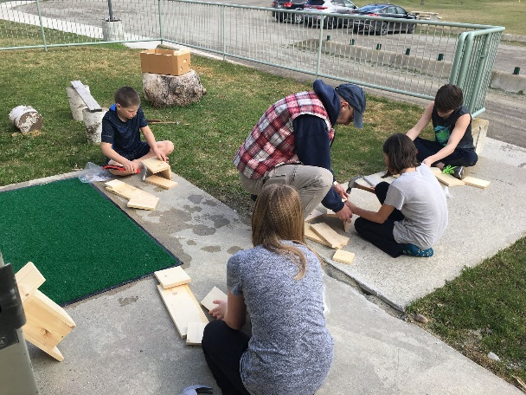
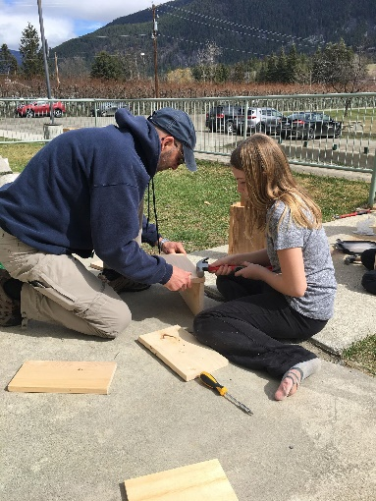

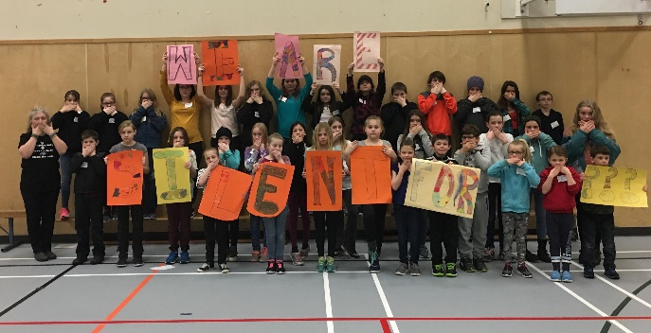
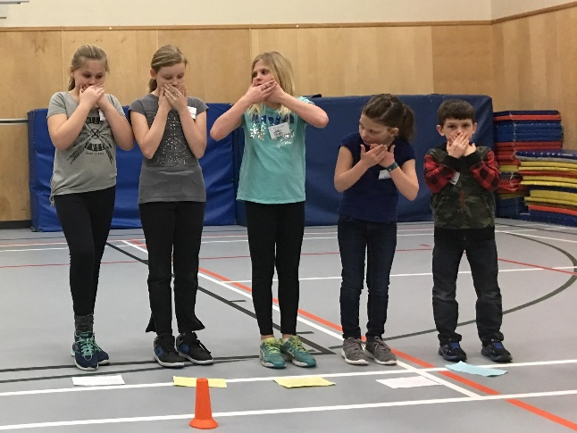
WE ARE SILENT is a campaign to raise awareness about an issue important to an individual student. We learn about ‘issues’ all the time, but when a student chooses something they truly believe in and it is something they feel within their heart, then it becomes something they are willing to stand up for. It is always an emotional moment for me to see children dig deep ‘loudly’ advocating for what they believe in. Many stood silent to bring awareness to mental health issues having already felt personal loss, many stood for the environment, some stood for clean water. Whatever the issue was, it was acknowledged and respected.
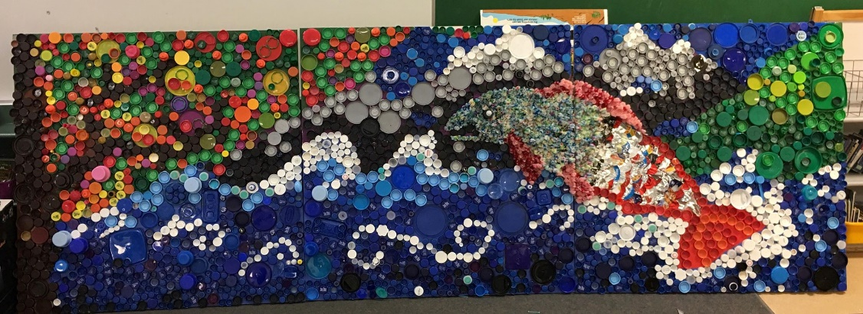
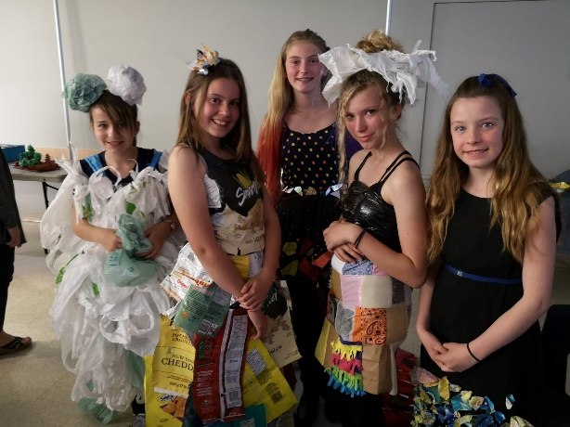
Focus on Youth!!!!! Wow, so many wonderful things happened this year. There was Mrs. Blackmore’s fashion show debuting fashionistas creating fashion out of reused plastic garbage bags, resewn fabric squares and even chip bags. It was amazing and students were even invited to a community event fashion show and, to me, they were the stars of the show! Junior and senior Be the Change students sang on stage – a students’ revised version of a song that focused on the environment, our over use of plastic, our need to think about our impact on nature and our need to care for it more wisely! Then there was the bottle cap mural! Honestly, it has created discussion throughout the valley! So much plastic! Why? Is it necessary? What’s the solution?

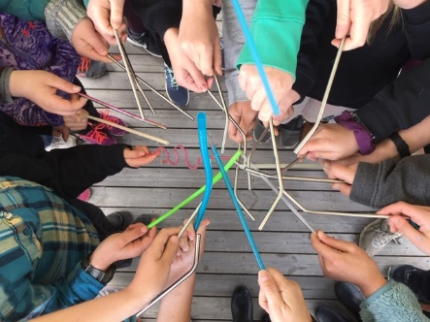
One of our primary goals this year was to learn about plastic and the effect it has upon our planet, ourselves and the creatures we share it with. We set goals to reduce plastic consumption on a personal level as well as within our community. Focus on Youth, the singing and the plastic art installation helped to create that initial awareness and inspired us to do more. Unfortunately, our wonderful vision to eliminate plastic straws in the town of Creston ran into time limitations and we just ran out of time to finish what we began. Students had begun researching, planning interviews of coffee shop and restaurant managers, putting together a presentation to forward to Town Council, but time would not allow. However, my hope is that along the way, our students learned many important facts about plastic and our role to create positive change about it’s usage. Paper straws? Stainless steel straws? Bring your own? Say, no thank you? Lots of decisions to make.

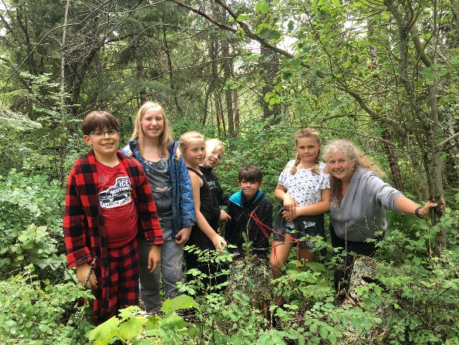
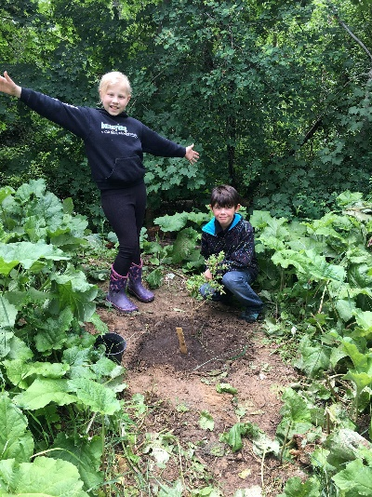
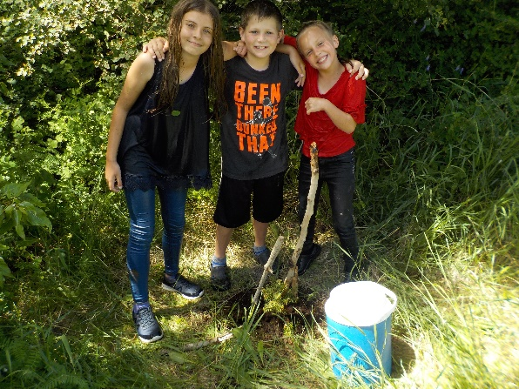
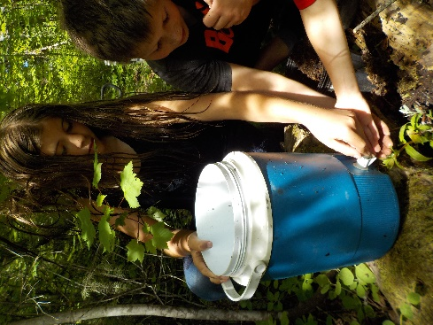
Throughout the Spring we have been planting in our Forest Garden. It is a magical place that students love to visit. It is a place of play, learning and connection. I always wish I could spend more ‘play time’ outside with students. However, we received a grant this year which allowed us to purchase a substantial amount of native plants with future plans to create a pathway of signage identifying English and Ktunaxa plant names and uses. Planting is hard work. Students, and teachers, are learning that it takes time, perseverance and dedication! Little plants need care! It’s a work in progress.
To celebrate our year together, as well as give back to our community, we conclude with visits to the Wildlife Center. Jr. Be the Changers took a naturalist course learning about the creatures and critters of the marsh and then it was time for a ‘relaxing’ canoe adventure. Okay, there might have been a bit of an issue paddling into the wind, but when all those muscles worked together, there was success! Made it back to shore – well done!
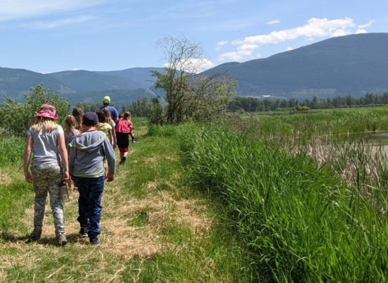
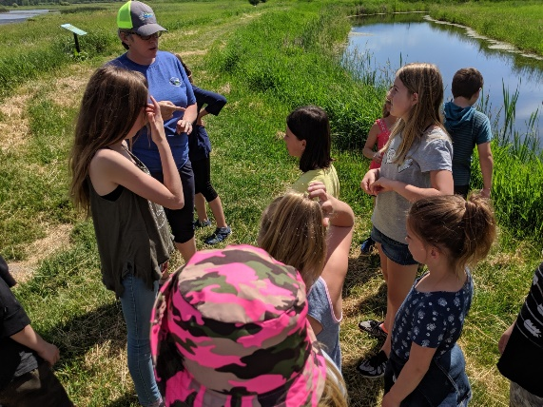
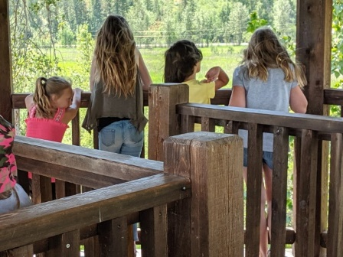

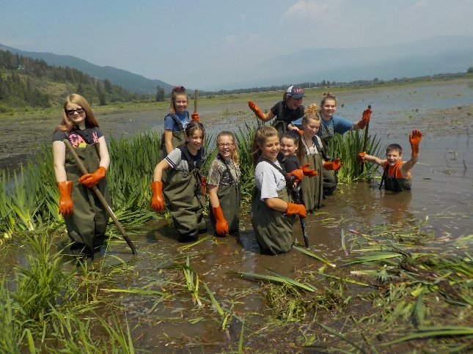
Sr. Be the Changers took it one step further, pulling invasive flag iris! That stuff was tough and muscles were again necessary to get the job done! Students worked hard, had fun and learned how important it is to plant only native species! Dilly bars were the sweet treat at the end of the day!
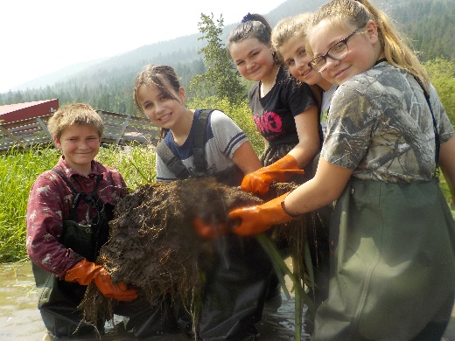
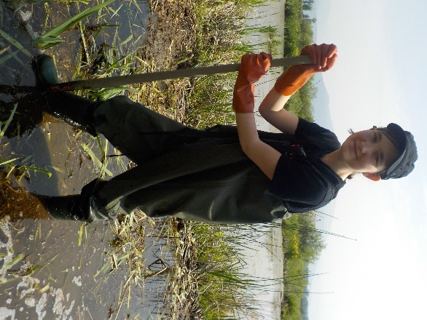
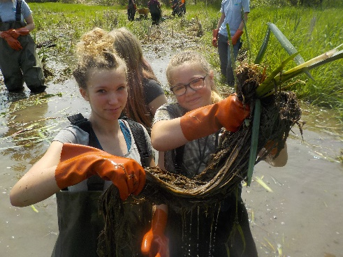
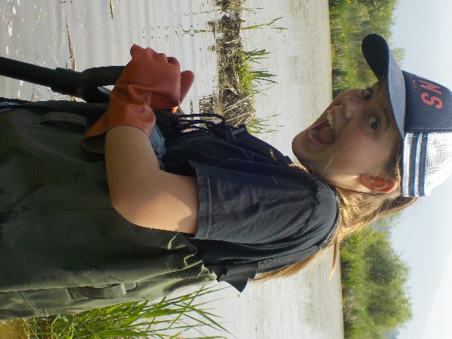
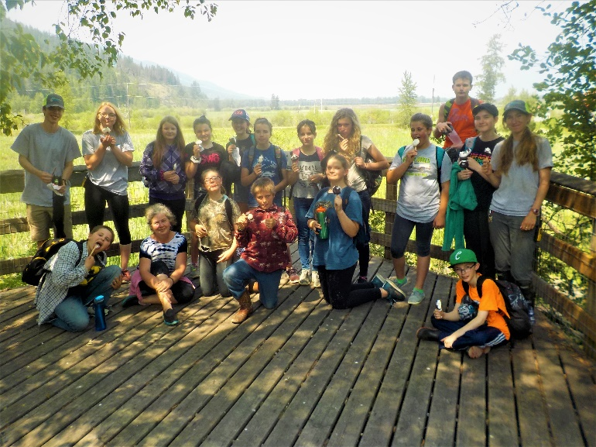

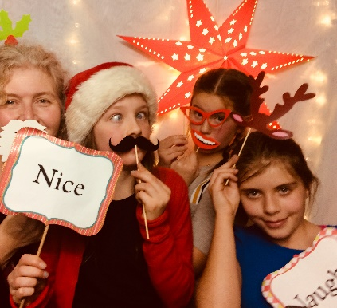

As many students know, I am passionate about our environment, but I am even more passionate about our students and what they learn while they attend our little school. Sometimes, I forget how much they’ve accomplished throughout the years and then I write the year end summary, and I remember! In amongst caring for others, planting trees, pulling weeds and putting words into actions, there has been joy! Thank you to our extended family, Ms. DeBoon, Mr. Ewashen and Miss Rachel for ALL the many extras. Thank you, Be the Changers, for caring about the world around you, standing up, running, walking for what you believe in. So proud of you all!
Happy summer, Mrs. E.!

