Aboriginal Education Newsletter – June 2022
Kisuk kyukyit !
And, another year has flown by!
May and June were beyond busy and yet, my hope is that we have all gained knowledge and shared kindness along the way!

May began with the sound of music! Amy Cross, a Metis educator, visited our school teaching us about Metis history as well as how the traditional music form of wooden spoons continues to be a beautiful way to express culture and stories. Each class learned a little song called the Taanishi Song by Faye Maurice and Norman Fleury. “Taanishi. Taanishi kiiya – Hello. How are you?” – Our talented students picked it up quickly and before you knew it, we were singing, laughing and playing spoons simultaneously – no easy feat !

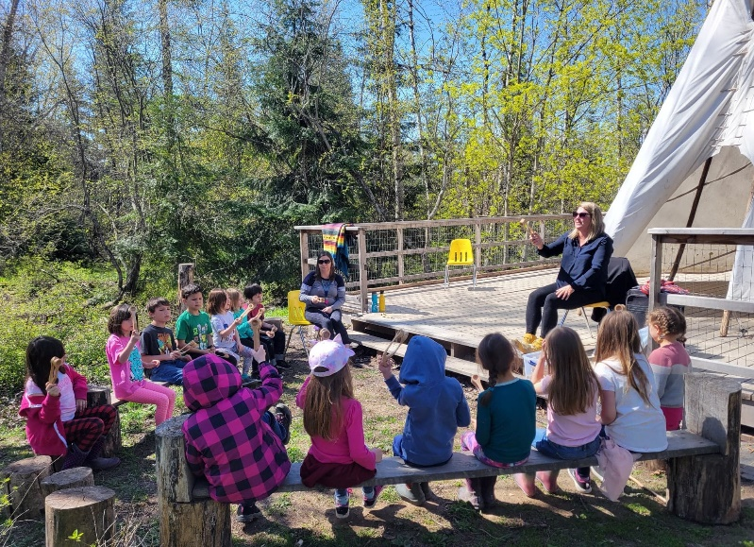
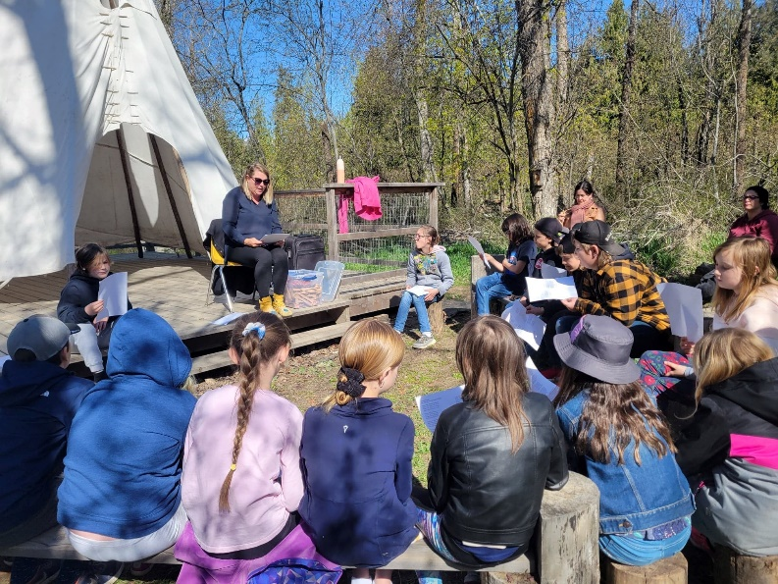

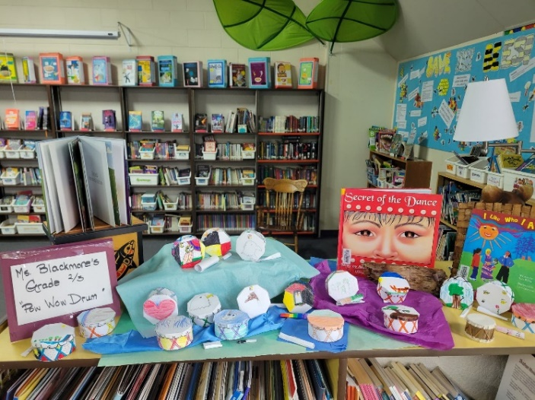
In May, we were joined by ‘Ms. Ya Ya’, an Ab Ed Support Worker from College of the Rockies. Lelainya spent hours each day working with individual students on their reading and math skills. It was fantastic!!! So lovely to have an extra set of hands and students benefitted greatly from the extra academic support.
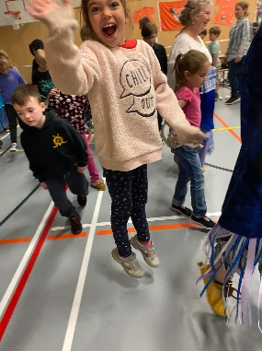
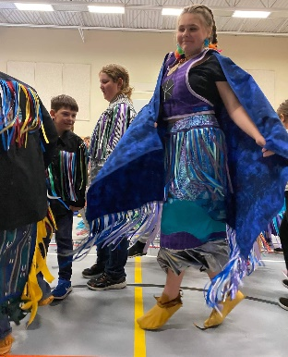
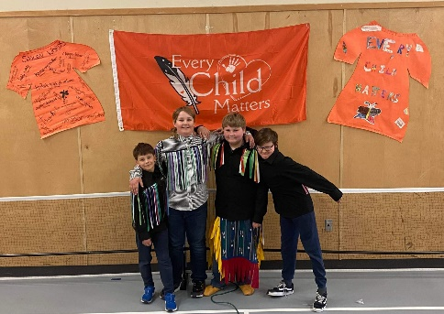
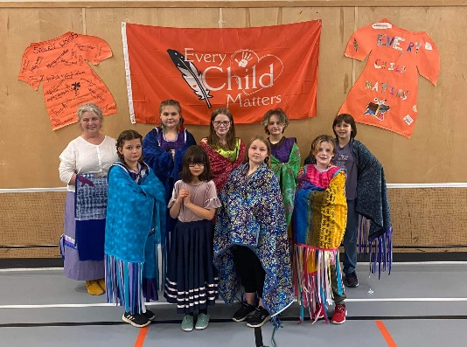
In the midst of it all, we prepared for Pow Wow. Each week there were virtual clips for classes to watch and participate in activities with. Some of us learned a few dance steps, some of us heard stories of acceptance and the gift of being who you are, some of us heard about traditions and resilience and we all had the opportunity to hear the drum beat of Mother Earth. Students became teachers as they shared the story of their own Regalia with student circles. I was so proud of each and every one of them as they explained the meanings of the ribbons, the significance of the ‘pictures’ on their Regalias and shared actual steps of the dance itself. Students generously shared their Regalias allowing others to try them on and even dance a little within our learning circle. Lunch hours were spent with students that worked hard to create a new piece of Regalia: moccasins, shawls, yokes, ribbon shirts. Each piece was worn with pride during the special day . Pow Wow was virtual, but at least we were able to spend it together as a school community. We met in the gym, to watch the virtual pow wow; dancers dancing either jingle, fancy or grass were displayed upon our huge screen and we all danced together ! It was amazing to see the joy on students’ faces as we danced, visited and listened as a school family.

On June 20th we honoured national Indigenous Day (June 21st). We worked within our classrooms to learn about the meaning of Reconciliation – what does it mean to repair a relationship???? Then, students created ‘Backpocket Promises” which they carried with them as the walked or ran the Reconciliation Walk around the school yard and forest. The K-Grade 5 classes sang the Travelling Song – to think of those that have travelled before us, our travels of today and those yet to come, thinking of ways to create new relationships, new ways of learning and safety for all travelers. Pretty beautiful! The afternoon was spent participating in fun activities that reflected a traditional Indigenous skill or plain old, forever important acts of kindness and respect! Oh yes – there was dancing, too!!!!

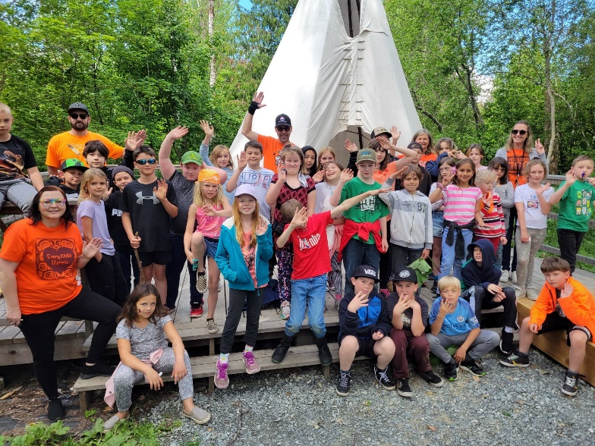
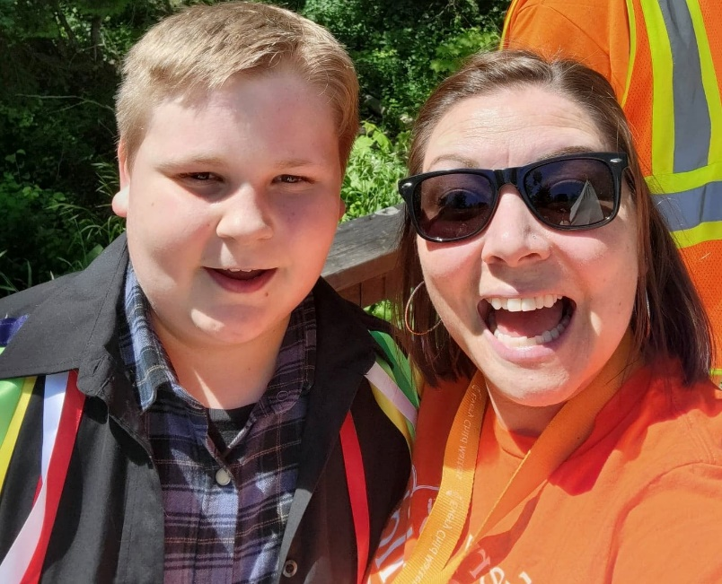

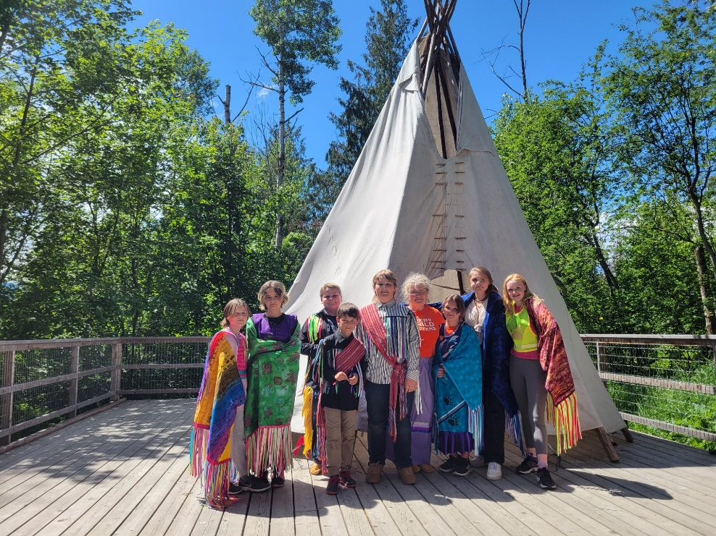

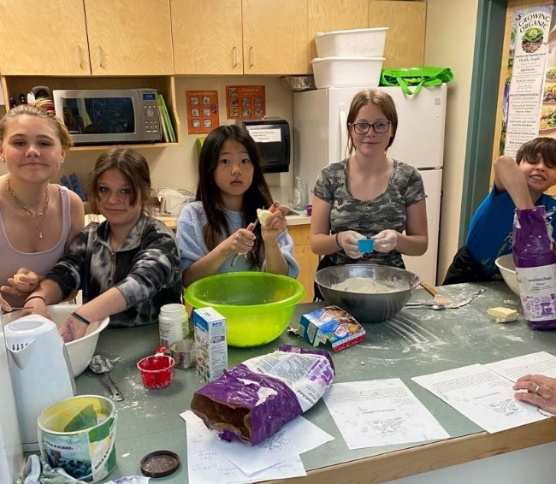
We were able to hold a few bannock fundraisers towards the end of the year. Oh my goodness – do children love bannock????? Yes, they do! That includes staff, too! And, I must say, it was some of the most delicious bannock made by students!!!! Umm, Umm good!

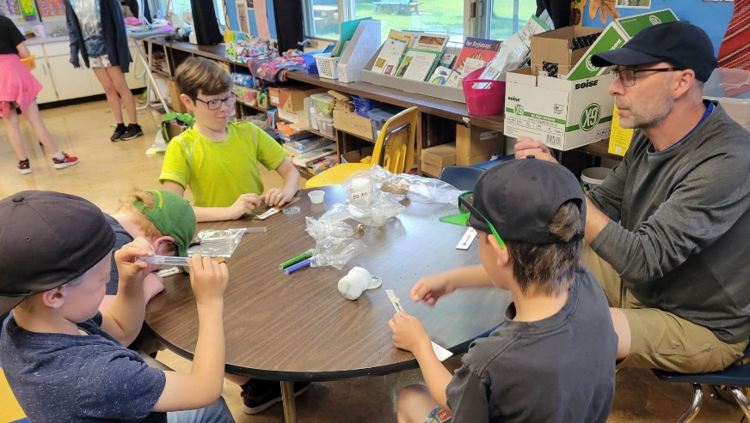

Throughout the year there have been several beading projects – some ongoing and others as class projects. They have become masterpieces and inspired several to continue on with their new found art work!!!!!!!
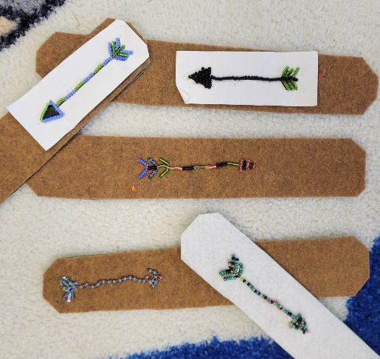
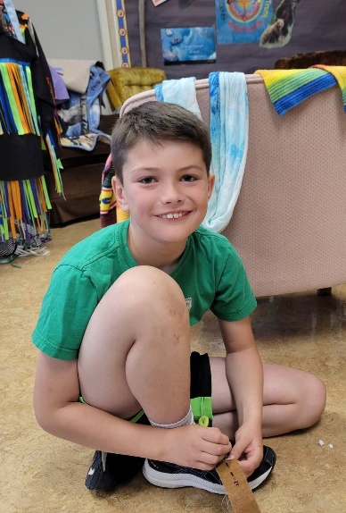
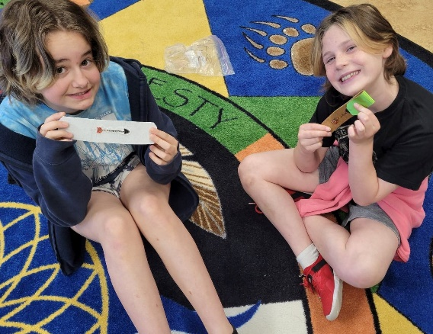

My ten, or so , years at Canyon Lister Elementary has been a gift. However, life has come full circle for me and I have made the decision to retire this year. My position has been posted, however, for now - Ms. Carriere is your contact for the Fall . My hope that is for a smooth transition in September for both students and families.

I have been so very humbled to been given the responsibility to teach and share time with your amazing children. We’ve read together, shared sooooo many stories together, we’ve created together, adventured together, ate bannock together , sometimes faltered together and always learned together. Your children have brought me so much joy and I hope I’ve found a way to touch their hearts and leave with them the message to be proud of who they are, to always strive to learn more, and to celebrate the amazing gifts we have to share- our planet, ourselves and each other. We have much to be grateful for. Take good care, everyone.

With love, Mrs. E.
